- The bar has constant radius of 0.05m and is composed of two different materials. The two ends A and C are fixed to the wall. An external load P of 380 kN is applied at point D. The modulus of elasticity of part AB and BC is 80 GPa and 200 GPa, respectively. Determine the reactions at ends A and C. (10’ in total)
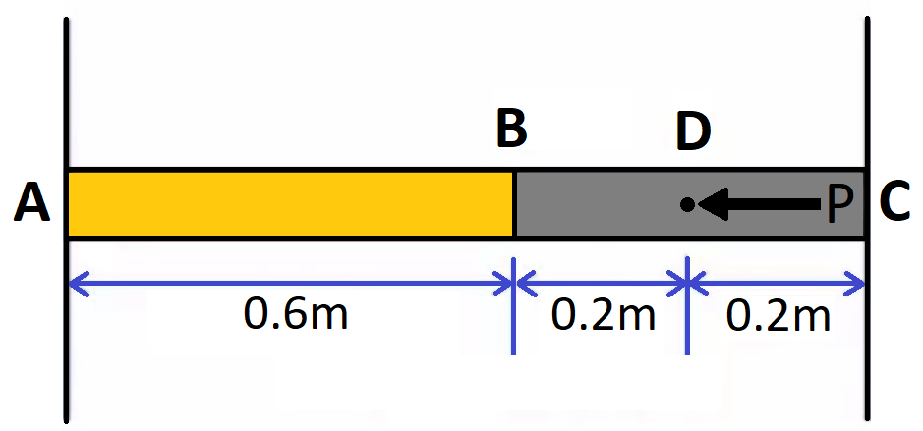

Compatibility Formula
$$δ_{AB}=-δ_{BC}$$
FBD
$$N_{A}+N_{C}-P=0→N_{A}+N_{C}-380,000N=0$$
Finding the formulas for each segments and sub segment’s change in length(δ).
$$δ_{BC}=δ_{BD}+δ_{DC}$$
$$δ_{AB}=-\frac{N_{A}*L_{AB}}{A*E_{AB}}; δ_{BD}=-\frac{N_{A}*L_{BD}}{A*E_{BC}}; δ_{DC}= \frac{N_{C}*L_{DC}}{A*E_{BC}}$$
$$δ_{BC}=-\frac{N_{A}*L_{BD}}{A*E_{BC}}+\frac{N_{C}*L_{DC}}{A*E_{BC}}$$
Rewriting the compatibility Formula
$$N_{A}+N_{C}-380,000N=0→N_{C}=380,000N-N_{A}$$
$$δ_{AB}=-δ_{BC}→-\frac{N_{A}*L_{AB}}{A*E_{AB}}=-\left(-\frac{N_{A}*L_{BD}}{A*E_{BC}}+\frac{N_{C}*L_{DC}}{A*E_{BC}}\right)→$$
$$\frac{N_{A}*L_{AB}}{A*E_{AB}}=-\frac{N_{A}*L_{BD}}{A*E_{BC}}+\frac{(380000-N_{A})*L_{DC}}{A*E_{BC}}$$
Listing the constants
$$A={0.05}^{2}*π=0.0025π$$
$$E_{AB}=80*{10}^{9} Pa$$
$$E_{BC}=200*{10}^{9} Pa$$
$$L_{BD} \& L_{DC}=0.2m$$
$$L_{AB}=0.6m$$
Solving The Equation
$$\frac{N_{A}*L_{AB}}{A*E_{AB}}=-\frac{N_{A}*L_{BD}}{A*E_{BC}}+\frac{\left(380000-N_{A}\right)*L_{DC}}{A*E_{BC}}→$$
$$\frac{N_{A}*0.6}{0.0025π*80*{10}^{9}}=-\frac{N_{A}*0.2}{0.0025π*200*{10}^{9}}+\frac{\left(380000-N_{A}\right)*0.2}{0.0025π*200*{10}^{9}}→N_{A}=40kN$$
$$N_{C}=380000-N_{A}=380-40=340kN$$

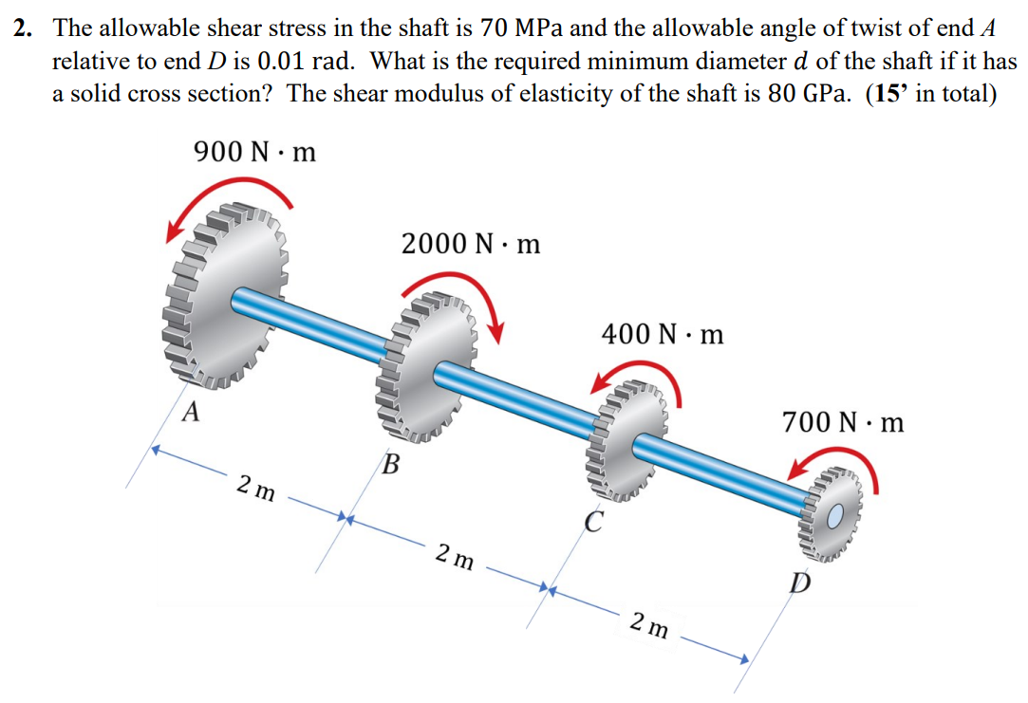
$$J=\frac{π}{2}*r^{4}$$
$$τ=\frac{T*r}{J};ϕ=\frac{T*L}{J*G}$$

Solving for Diameter with shear stress:
$$T_{AB}=-900;T_{BC}=1100;T_{CD}=700$$
$$τ=\frac{T*r}{J}→70*{10}^{6}=\frac{1100*r}{\frac{π}{2}*r^{4}}→r≅0.02m→d=0.043$$
Solving for diameter with angle.
$$ϕ=\frac{T*L}{J*G}→0.01=\frac{-900*2+1100*2+700*2}{\frac{π}{2}*r^{4}*80*{10}^{9}}→r=0.0346m→d=0.0692m$$
Compare the diameters
$$0.0692>0.043, so Final diameter=0.0692m$$

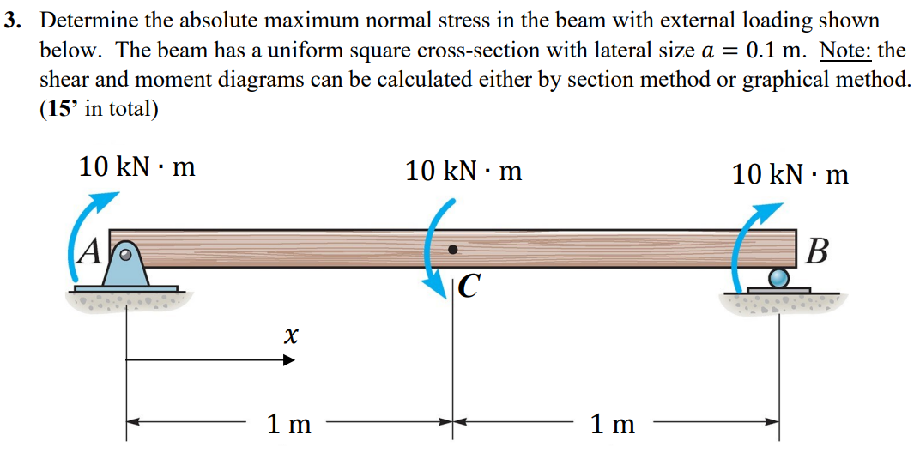
Draw Moment Diagram
$$∑F_{Y}=0; R_{A}+R_{B}=0$$
$$∑M_{A}=0;10-10+10-R_{B}*2m=0$$
$$R_{B}=5kN, thus R_{A}=-5kN$$
$$This results in a constant shear diagram at -5kN$$
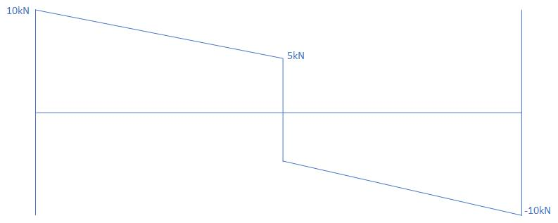
$$I=\frac{1}{12}*b*h^{3}$$
$$I=\frac{1}{12}*0.1*{0.1}^{3}$$
$$σ=\frac{Mc}{I}→\frac{10000*\frac{1}{2}*0.1}{\frac{1}{12}*0.1*{0.1}^{3}}=60 MPa$$
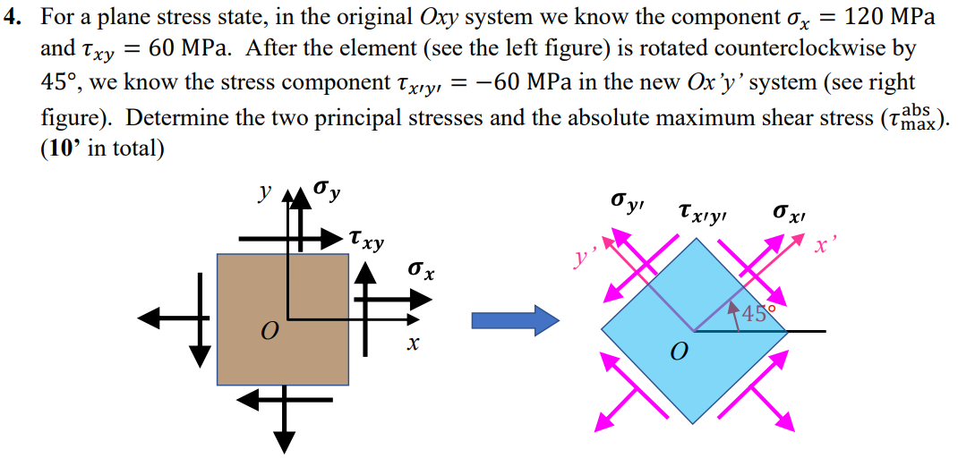
$$σ_{avg}=\frac{σ_{x}+σ_{y}}{2}=60MPa$$
$$R=\sqrt{{\left(\frac{σ_{x}-σ_{y}}{2}\right)}^{2}+τ_{xy}^{2}}=\sqrt{60MPa^{2}+60MPa^{2}}=84.853MPa$$
$$σ_{1,2}=60±84.853→σ_{1}=144.853;σ_{2}=-24.853$$
$$σ_{x^{'}}=60+60=120MPa$$
$$σ_{y^{'}}=0$$
$$τ_{x^{'}y^{'}}=-60MPa$$
$$τ_{\begin{matrix}abs \\ max\end{matrix}}=\frac{σ_{1}-σ_{2}}{2}=\frac{144.853-(-24.853)}{2}=84.853$$
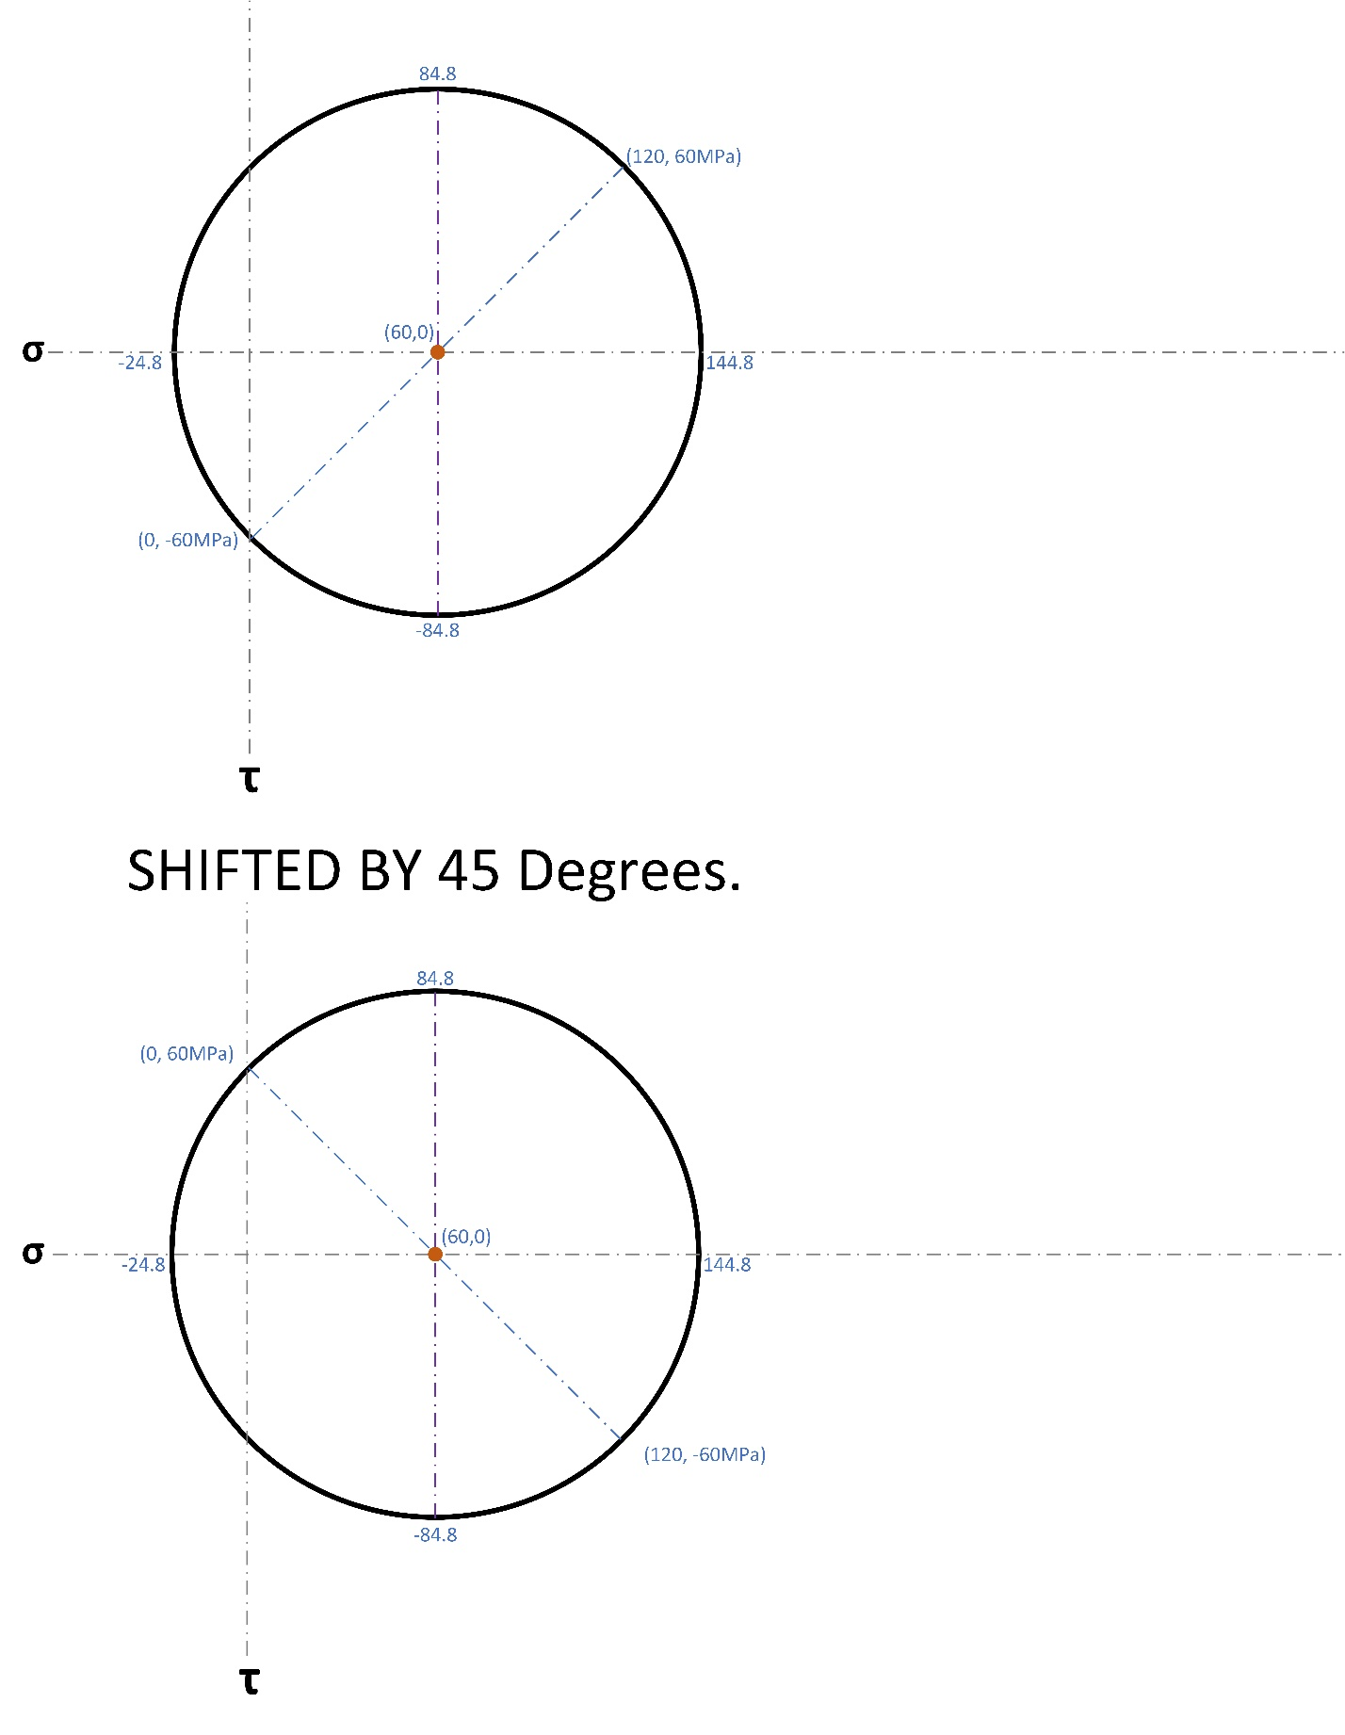
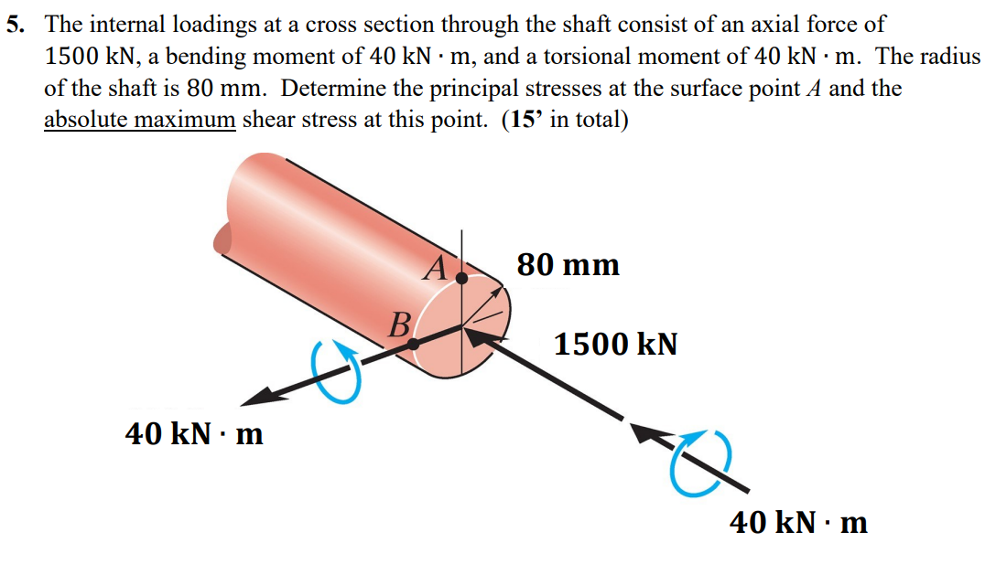
$$I_{x}=\frac{π}{4}*r^{4}=\frac{π}{4}*{0.08}^{4}; J=\frac{π}{2}*r^{4}=\frac{π}{2}*{0.08}^{4}$$
$$τ_{xy} =\frac{Tc}{J}=\frac{40000*0.08}{\frac{π}{2}*{0.08}^{4}}=\frac{156250000}{π}≅49.735MPa$$
$$σ_{x}=\frac{Mc}{I}+\frac{N}{A}=-\frac{40000*0.08}{\frac{π}{4}*{0.08}^{4}}-\frac{1500000}{{π*0.08}^{2}}=-\frac{546875000}{π}≅-174.07MPa$$
$$σ_{1,2}=\frac{σ_{x}+σ_{y}}{2}±\sqrt{{\frac{σ_{x}-σ_{y}}{2}}^{2}+τ_{xy}^{2}}$$
$$σ_{1}=-\frac{\left(\frac{546875000}{π}\right)}{2}+\sqrt{{\frac{\frac{546875000}{π}}{2}}^{2}+{\left(\frac{156250000}{π}\right)}^{2}}=\frac{39062500\sqrt{65}-273437500}{π}=13.2MPa$$
$$σ_{2}=-\frac{\left(\frac{546875000}{π}\right)}{2}-\sqrt{{\frac{\frac{546875000}{π}}{2}}^{2}+{\left(\frac{156250000}{π}\right)}^{2}}=-\frac{39062500\sqrt{65}+273437500}{π}=-187.3MPa$$
$$τ_{\begin{matrix}abs \\ max\end{matrix}}=\frac{\frac{39062500\sqrt{65}-273437500}{π}-\left(-\frac{39062500\sqrt{65}-273437500}{π}\right)}{2}=100.24MPa$$
$$C=-\frac{\left(\frac{546875000}{π}\right)}{2}=-87MPa$$
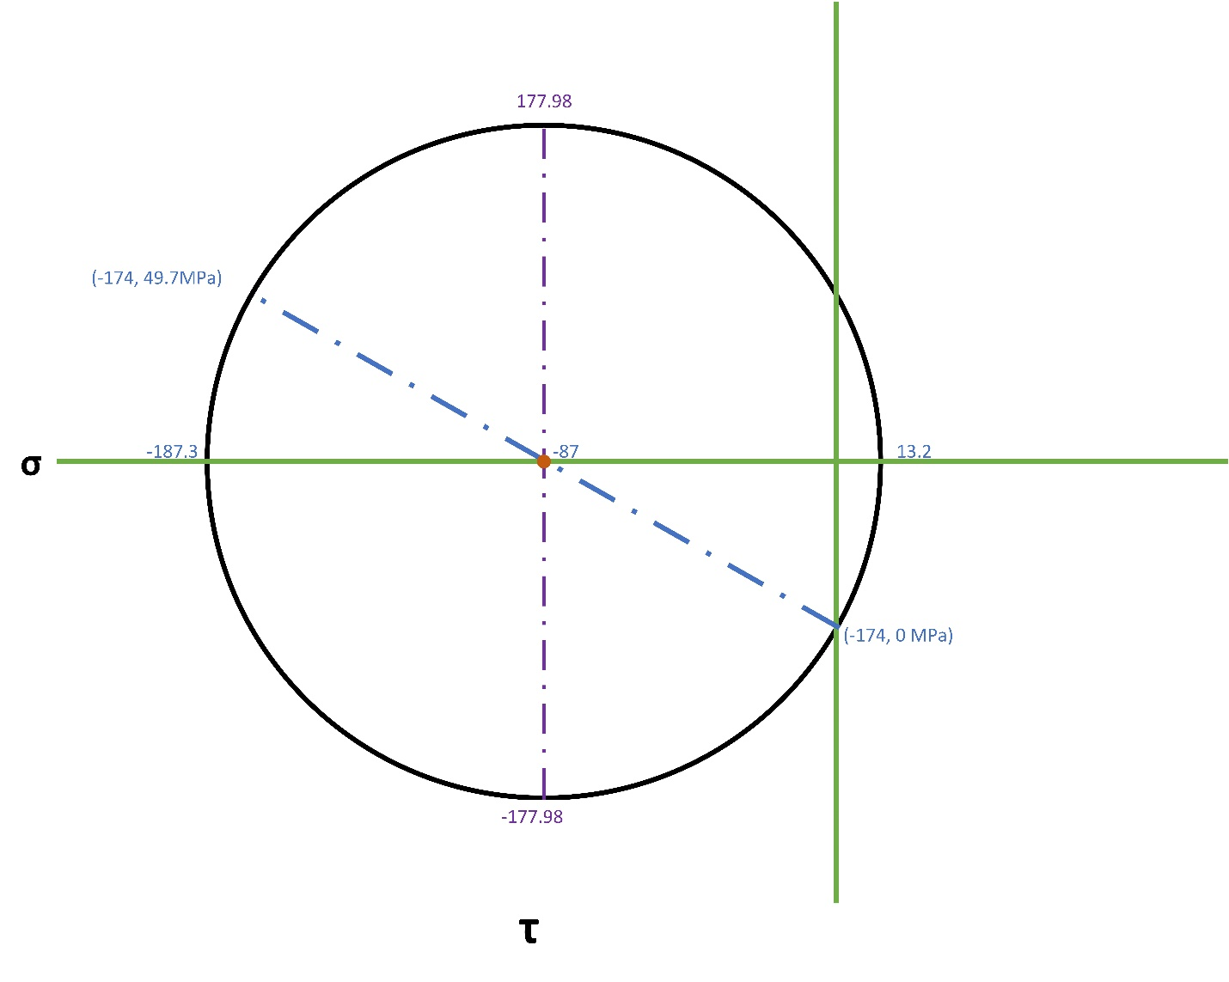

6. A thin-walled cylindrical pressure vessel of inner radius 𝑟 = 0.006m and a thickness of
0.0006m is subjected simultaneously to internal gas pressure 𝑝 = 3.5 MPa, a compressive
force 𝐹 = 800 N acting at the ends, and a torsional load of 25 N · m (see figure). Determine the following quantities (15’ in total):
Hint: the cross-section of the vessel can be regarded as a hollow tube and the cross-section area can be calculated as 𝜋*(0.0066² - 0.006²). You can do the same treatment for the polar moment inertia.
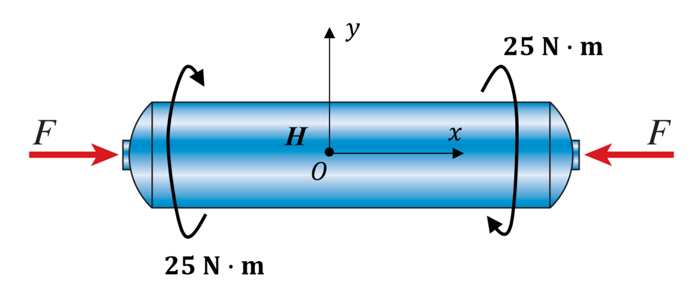
(a) The principal stresses at a point H on the surface of the vessel and the absolute maximum shear stress; (10’)
$${\left(σ_{x}\right)}_{F}=-\frac{F}{A}=-\frac{F}{π*\left({\left(r+t\right)}^{2}-r^{2}\right)}≅-33.7MPa$$
$$σ_{hoop}=\frac{pr}{t}=35MPa;σ_{long}=\frac{pr}{2t}=17.5MPa$$
$$σ_{x}=\frac{pr}{2t}-\frac{F}{π*\left({\left(r+t\right)}^{2}-r^{2}\right)}≅-16.2MPa;σ_{y}=\frac{pr}{t}=35MPa$$
$$τ_{xy}=\frac{Tc}{J}=\frac{T*(r+t)}{\frac{π}{2}*\left({\left(r+t\right)}^{4}-r^{4}\right)}≅174.6$$
$$C=\frac{\frac{pr}{2t}-\frac{F}{π*\left({\left(r+t\right)}^{2}-r^{2}\right)}+\frac{pr}{t}}{2}=9.4MPa;$$
$$R=\sqrt{{\frac{\frac{pr}{2t}-\frac{F}{π*\left({\left(r+t\right)}^{2}-r^{2}\right)}-\frac{pr}{t}}{2}}^{2}+{\frac{T*(r+t)}{\frac{π}{2}*\left({\left(r+t\right)}^{4}-r^{4}\right)}}^{2}}=177.98 MPa;$$
$$σ_{1,2}=\frac{σ_{x}+σ_{y}}{2}±\sqrt{{\frac{σ_{x}-σ_{y}}{2}}^{2}+τ_{xy}^{2}}$$
$$=\frac{\frac{pr}{2t}-\frac{F}{π*\left({\left(r+t\right)}^{2}-r^{2}\right)}+\frac{pr}{t}}{2}±\sqrt{{\frac{\frac{pr}{2t}-\frac{F}{π*\left({\left(r+t\right)}^{2}-r^{2}\right)}-\frac{pr}{t}}{2}}^{2}+{\frac{T*\left(r+t\right)}{\frac{π}{2}*\left({\left(r+t\right)}^{4}-r^{4}\right)}}^{2}}$$
$$σ_{1}=\frac{\frac{pr}{2t}-\frac{F}{π*\left({\left(r+t\right)}^{2}-r^{2}\right)}+\frac{pr}{t}}{2}+\sqrt{{\frac{\frac{pr}{2t}-\frac{F}{π*\left({\left(r+t\right)}^{2}-r^{2}\right)}-\frac{pr}{t}}{2}}^{2}+{\frac{T*\left(r+t\right)}{\frac{π}{2}*\left({\left(r+t\right)}^{4}-r^{4}\right)}}^{2}}=178.7 MPa$$
$$σ_{2}=\frac{\frac{pr}{2t}-\frac{F}{π*\left({\left(r+t\right)}^{2}-r^{2}\right)}+\frac{pr}{t}}{2}-\sqrt{{\frac{\frac{pr}{2t}-\frac{F}{π*\left({\left(r+t\right)}^{2}-r^{2}\right)}-\frac{pr}{t}}{2}}^{2}+{\frac{T*\left(r+t\right)}{\frac{π}{2}*\left({\left(r+t\right)}^{4}-r^{4}\right)}}^{2}}=-177.26 MPa$$
$$τ_{\begin{matrix}abs \\ max\end{matrix}}=\sqrt{{\frac{\frac{pr}{2t}-\frac{F}{π*\left({\left(r+t\right)}^{2}-r^{2}\right)}-\frac{pr}{t}}{2}}^{2}+{\frac{T*\left(r+t\right)}{\frac{π}{2}*\left({\left(r+t\right)}^{4}-r^{4}\right)}}^{2}}=177.98MPa$$
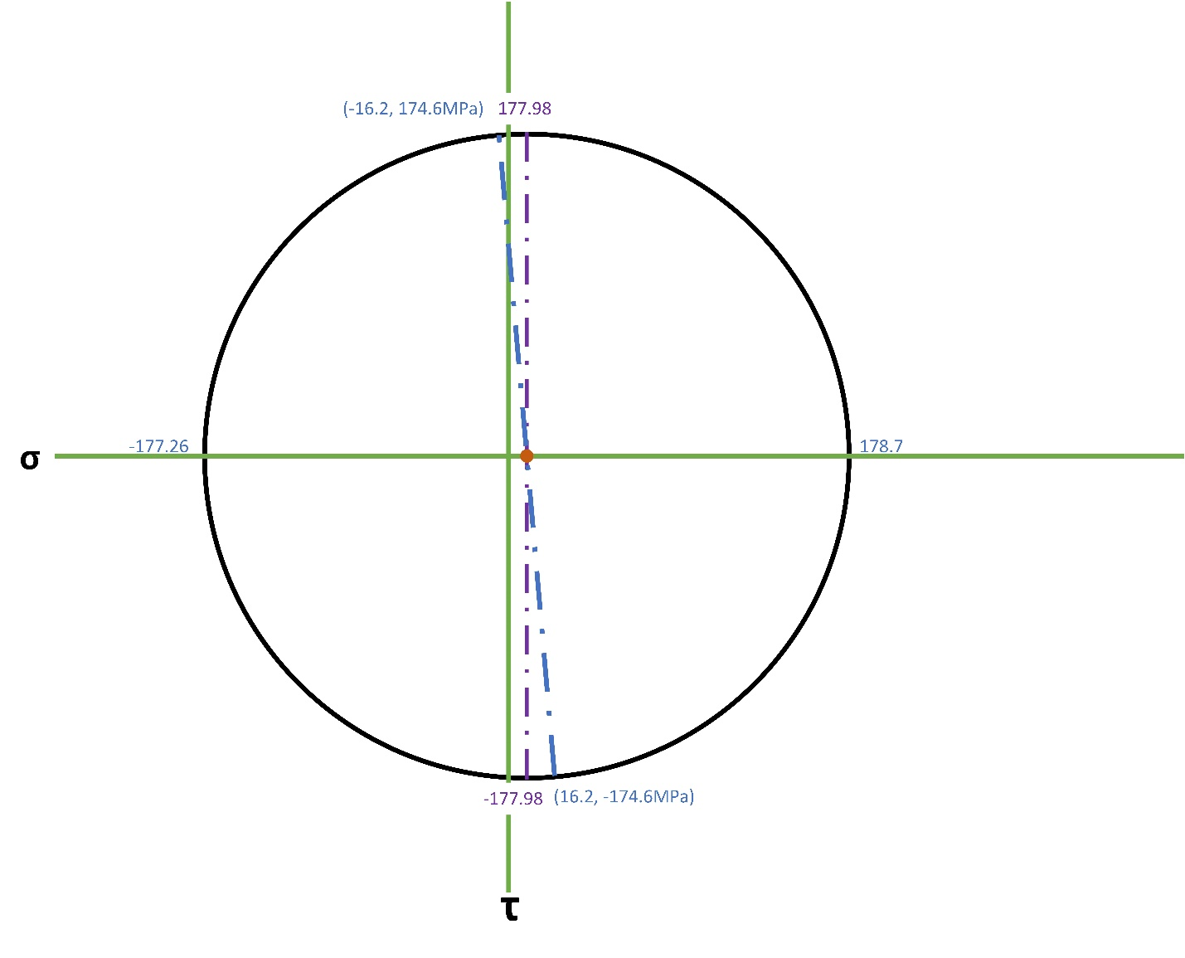
(b) The normal strain along x-axis (𝜀_{𝑥}) and the shear strain (𝛾_{𝑥𝑦}) at the same point H. See the established O_{xy} coordinate system. The Young’s modulus of the material is 200 GPa and the Poisson’s ratio is 0.3. (5’)
$$ε_{x}=\frac{1}{E}\left(σ_{x}-v*σ_{y}\right)=\frac{1}{2*{10}^{11}}\left(\frac{pr}{2t}-\frac{F}{π*\left({\left(r+t\right)}^{2}-r^{2}\right)}-v*\frac{pr}{t}\right)=-1.33*{10}^{-4}$$
$$ε_{y}=\frac{1}{E}\left(σ_{y}-v*σ_{x}\right)=\frac{1}{2*{10}^{11}}\left(\frac{pr}{t}-v*\left(\frac{pr}{2t}-\frac{F}{π*\left({\left(r+t\right)}^{2}-r^{2}\right)}\right)\right)=1.993*{10}^{-4}$$
$$G=\frac{E}{2\left(1+v\right)}=2*\frac{{10}^{11}}{2+2*0.3}=\frac{{10}^{12}}{13}$$
$$γ_{xy}=\frac{τ_{xy}}{G}=\frac{\left(\frac{T*(r+t)}{\frac{π}{2}*\left({\left(r+t\right)}^{4}-r^{4}\right)}\right)}{\left(\frac{{10}^{12}}{13}\right)}=2.27*{10}^{-3}$$

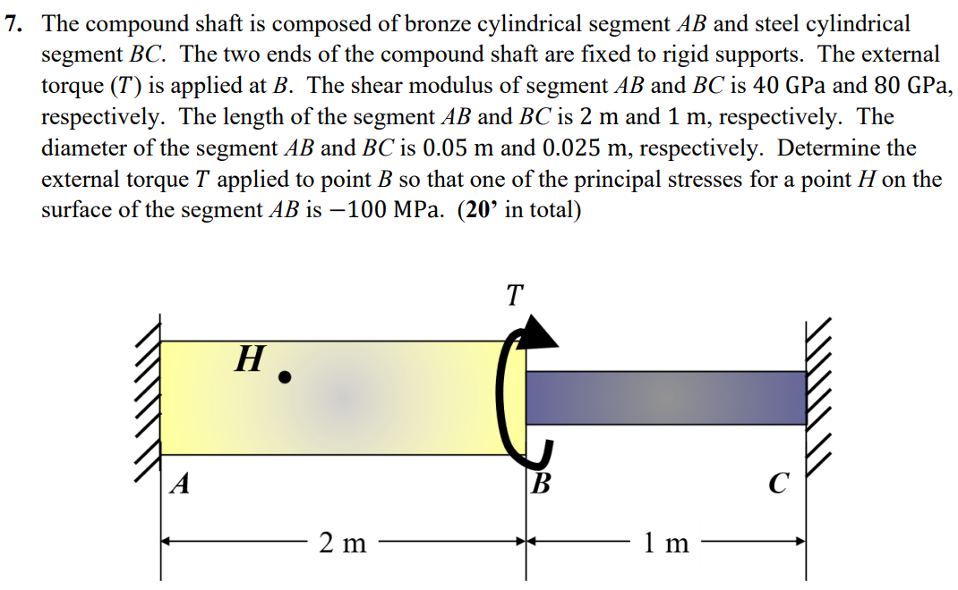
Compatibility formula
$$T=T_{AB}+T_{BC}$$
$$ϕ_{AB}+ϕ_{BC}=0$$
$$\frac{T_{AB}*L_{AB}}{J_{AB}*G_{AB}}+\frac{T_{BC}*L_{BC}}{J_{BC}*G_{BC}}=0→\frac{T_{AB}*2}{\frac{π}{2}*{0.025}^{4}*40*{10}^{9}}=\frac{T_{BC}*1}{\frac{π}{2}*{0.0125}^{4}*80*{10}^{9}}→\frac{T_{AB}*2}{\frac{π}{2}*{0.025}^{4}*40*{10}^{9}}+\frac{\left(T-T_{AB}\right)*1}{\frac{π}{2}*{0.0125}^{4}*80*{10}^{9}}=0$$
$$\frac{T_{AB}*2}{\frac{π}{2}*{0.025}^{4}*40*{10}^{9}}+\frac{\left(T-T_{AB}\right)*1}{\frac{π}{2}*{0.0125}^{4}*80*{10}^{9}}=0→T=\frac{5}{4}T_{AB}$$
$$σ_{1,2}=C±R→no σ_{x} or σ_{y} and the square root will cancel out, so we use τ_{xy}=±\frac{Tc}{J}→$$
$$100MPa=\frac{T_{AB}*0.025}{\frac{π}{2}*{0.025}^{4}}→T_{AB} Max=2454.36 N*m$$
$$T=\frac{5}{4}T_{AB}→\frac{5}{4}*2454.36=3067.96N*m$$

